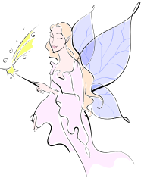
B-2 Halloween II Mystical Forest
PhotoShop Techniques: Matching resolution/image size on 3 images,
selecting, using liquefy filter, adjusting opacity

Open three images: FairyForest, nalith, butterfly wings.
- All three have already had their resolution set to 100 and the image size adjusted to be proportional to one another: FairForest will be large enough to fit an 8.5 x 11” page, Nalith will be half the height, wings will be about same size or larger than Nalith.

Open Nalith.gif from global drive.
- I have already removed the background, but you will need to remove the background in the picture of you.,
- Liquify Filter: Use the Liquefy filter to gently warp her ears and eyebrows—put all setting on 50 and use a gentle touch!
- Hue/Saturation Adjustment: Select Nalith’s face, neck, and hair, but then subtract out her eyes and mouth using a very small brush. Add a hue/saturation layer to desaturate her and change the hue to make her a light pink (to the right).
- Merge the layers so far.
- Render Filter: Filter > render > lighting effects > Omni > move light source under her chin—change the light color on the top to a light pink; try adjusting the size of the Omni oval.
- Copy Nadia to the background FairyForest and place in a realistic way.

Open butterfly wings from global drive.
- Unlock the background
- Remember, I have already set the size/resolution to match the girl!
- Delete the white background: Use the magic wand to select the white background > delete.
- Hue/Saturation: Make the wings have a pink hue.
- Merge the wing layers.
- Copy/drag the wings to background photo; adjust Layers Palette so that wings are behind Nadia.
- Opacity: lower the opacity of the wing layer to make the wings look transparent.
- Add a new layer above the wings: on this new layer with the Assorted paint brush #50, add sparkles in various places and sizes in white.
- Outer glow: add an outer glower layer style to the paint brush layer to make the sparkles glow.

- Add the title shown above “Mystical Forest”—Script font, 100 pt. white, with a Text Warp, and following Layer Styles (drop shadow, black stroke 1 pt size).

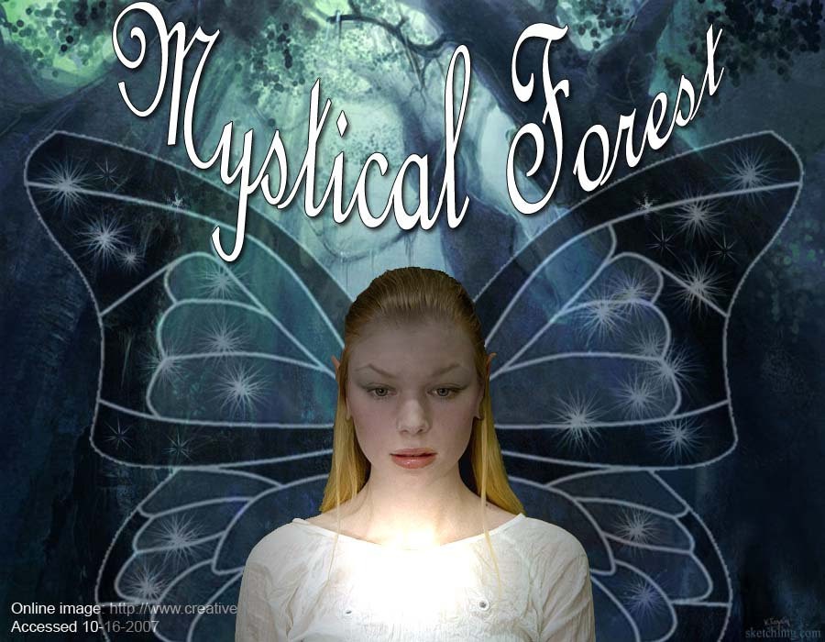
Sample of classwork

Rubric – Assignment B-2 Halloween 2 – Remember to give permission for me to post your picture and enter you in the contest!

Requirements | Pts possible | Pts earned
Girls and Boys alike – Turn your personal photo into a forest creature with “wings” and paste yourself into a new forest or fairylike background. You can use other wings if you prefer (e.g., Dragon wings, angel wings). Start by finding 2 pictures from the Internet for the background and the wings. Next set all 3 images to a resolution of 100 and resize each to work together to fit on the background.
Must use the following:
- Paint brush sparkles on the wings (Assorted brush #50) with an outer glow Layers Style applied. | 3
- Evidence of gentle warping on your face—ears, eyebrows | 5
- Omni lighting effects on your face. | 5
- Lowered opacity on your wings (not to be less than 50%) | 5
- Appropriate title in an effective text layer (font, size, layer style, warping). | 5
- Quality of the resolution of each part: the background, your photo, the wings. The quality will look good only if you remembered to set the resolution of each picture to 100 and set the size of that photo to work well with the other two. You cannot just rely on Free Transform to adjust sizes! | 5
- Print to the color printer. May use landscape or portrait, but be sure the orientation fits the background picture.  ”Designed by…” (student name) is printed in lower right hand corner.  - Site your picture source from the Internet! | 2
Total pts | 3ssi0

